**SKILL AND JOB RECOMMENDER USING**

**CLOUD COMPUTING**

**NALIYATHIRAN PROJECT BASED LEARNING**

on

**PROFESSIONAL READINESS FOR INNOVATION, EMPLOYABILITY AND**

**ENTERPRENUERSHIP**

**A PROJECT REPORT**

**Submitted by**

KAMALARAJ S M (960519104036)

GOVARTHAN P R (960519104027)

PREMKUMAR R (960519104057)

HERILSON ALBERT A (960519104030)

***in partial fulfillment for the award of the degreeof***

**Bachelor of Technology**

**in**

**computer science engineering**

**CAPE institute of technology**

P.O, Levengipuram (near Anjugramam, Rajakrishnapuram, Tamil Nadu 627114

**Anna University, Chennai – 600 025**

**NOVEMBER 2022**

**CAPE institute of technology**



**INTERNAL MENTOR**

**M.SINTHU**

ASSISTANT PROFESSOR,

Department of **computer science engineering**

**CAPE institute of technology**

**INDUSTRY MENTORS**

**Krishna Chaitanya**

**ABSTRACT**

Machine learning is a sub-field of data science that concentrates on designing algorithms that can learn from and make predictions on the data. Presently recommendation frameworks are utilized to take care of the issue of the overwhelming amount of information in every domain and enable the clients to concentrate on information that is significant to their area of interest. One domain where such recommender systems can play a significant role to help college graduates to fulfill their dreams by recommending a job based on their skill set. Currently, there are plenty of websites that provide heaps of information regarding employment opportunities, but this task is extremely tedious for students as they need to go through large amounts of information to find the ideal job. And many students are not aware of which job is suitable for them. Nowadays, the IT fields are in a boom. Many engineering students are learning some technical skills by doing some courses but they don’t know which skill is for which job. Simultaneously, existing job recommendation systems only take into consideration the domain in which the user is interested while ignoring their profile and skillset, which can help recommendobs that are tailor-made for the user. This paper examines the user’s resume then compares the knowledge of degree, soft skills, hard skills, and the projects he has done and then only the system recommends the jobs for that user. The system not only recommends the jobs but also shows the score of his/her resume for the respective job. Then, the system also recommends skills to improve the scores of theirMachine learning is a subfield of data science that concentrates on designing algorithms that can learn from and make predictions on the data. Presently recommendation frameworks are utilized to take care of the issue of the overwhelming amount of information in every domain and enable the clients to concentrate on information that is significant to their area of interest. One domain where such recommender systems can play a significant role to help college graduates to fulfill their dreams by recommending a job based on their skill set. Currently, there are plenty of websites that provide heaps of information regarding 4 employment opportunities, but this task is extremely tedious for students as they need to go through large amounts of information to find the ideal job. And many students are not aware of which job is suitable for them. Nowadays, the IT fields are in a boom. Many engineering students are learning some technical skills by doing some courses but they don’t know which skill is for which job. Simultaneously, existing job recommendation systems only take into consideration the domain in which the user is interested while ignoring their profile and skillset, which can help recommend jobs that are tailor-made for the user. This paper examines the user’s resume then compares the knowledge of degree, soft skills, hard skills, and the projects he has done and then only the system recommends the jobs for that user. The system not only recommends the jobs but also shows the score of his/her resume for the respective job. Then, the system also recommends skills to improve the scores of theirMachine learning is a sub-field of data science that concentrates on designing algorithms that can learn from and make predictions on the data. Presently recommendation frameworks are utilized to take care of the issue of the overwhelming amount of information in every domain and enable the clients to concentrate on information that is significant to their area of interest. One domain where such recommender systems can play a significant role to help college graduates to fulfill their dreams by recommending a job based on their skill set. Currently, there are plenty of websites that provide heaps of information regarding employment opportunities, but this task is extremely tedious for students as they need to go through large amounts of information to f

**TABLE OF CONTENTS**

**Chapter No. Title Page no.**

1. **INTRODUCTION**
   1. Project Overview 01
   2. Purpose 02

1. **LITERATURE SURVEY**
   1. Existing Problem 04
   2. References 04
   3. Problem Statement Definition 04
2. **IDEATION & PROPOSED SYSTEM** 07
   1. Empathy Map Canvas 07
   2. Ideation & Brainstroming 07
   3. Proposed Solution 07
   4. Problem Solution Fit
3. **REQUIREMENT ANALYSIS**
   1. Functional Requirements 08
   2. Non - Functional Requirements 08

# PROJECT DESIGN

5.1 Data Flow Diagrams

5.2 Solution & Technical Architecture

5.3 User Stories

1. **PROJECT PLANNING AND SCHEDULING**
   1. Sprint Planning & Estimation
   2. Sprint Delivery Schedule
   3. Reports from JIRA

1. **CODING & SOLUTIONING**  
   1. Feature 1 7.2 Feature 2

7.3 Database Schema (if Applicable)

1. **TESTING**  
   1. Test Cases
   2. User Acceptance Testing
2. **RESULTS**  
   1. Perforamance Metrics
3. **ADVANTAGES & DISADVANTAGES**
4. **CONCLUSION**
5. **FUTURE SCOPE**
6. **APPENDIX**

Source Code

GitHub & Project Demo Link **Problem Statement Definition:**

In the last years, job recommender systems have become popular since they successfully reduce information overload by generating personalized job suggestions. Although in the literature exists a variety of techniques and strategies used as part of job recommender systems, most of them fail to recommend job vacancies that fit properly to the job seekers profiles. Thus, the contributions of this work are threefold, made publicly available a new dataset formed by a set of job seekers profiles and a set of job vacancies collected from different job search engine sites, put forward the proposal of a framework for job recommendation based on professional skills of job seekers, and carried out an evaluation to quantify empirically the recommendation abilities of two state-ofthe-art methods, considering different configurations, within the proposed framework. Thus present a general panorama of job recommendation task aiming to facilitate research and real-world application design regarding this important issue. Job matching, job seeking, job search, job recommender systems. Proposed a framework for job recommendation task. This framework facilitates the understanding of job recommendation process as well as it allows the use of a variety of text processing and recommendation methods according to the preferences of the job recommender system designer. Moreover, we also contribute making publicly available a new dataset containing job seekers profiles and job vacancies. Future directions of our work will focus on performing a more exhaustive evaluation considering a greater amount of methods and data as well as a comprehensive evaluation of the impact of each professional skill of a job seeker on the received job recommendation.

**EXISTING PROBLEM:**

The major contribution of this work is as follows: The large MNC businesses use the mechanism currently in place for employment recommendations. The method is employed by businesses, not by regular people. If not, they will charge a small subscription fee to check the user's career options. The system functions for the average guy from city to village to modify this predicament. Because the students would look for employment based on their own skills, this approach will reduce unemployment. This company will also grow more quickly, which will result in more job openings. The goal of the proposed work is to suggest a job that is ideal for the user. It displays the hierarchical jobs that are best for the user, not just one job. Additionally, it suggests skills for the jobs that were suggested for the user. This project is intended for someone who simply has no idea what they are going to do. Additionally, there are no logins available because doing so increases the likelihood that users would reject you. The subsequent chapter goes over the specifics of the implementation. The rest of the paper organizes as follows: Chapter 2 provides the literature review conducted for this project. Chapter 3 presents the System Design and Architecture of the project along with the methodology. Chapter 4 discusses the algorithms proposed in this project. Chapter 5 presents the project conclusion and future works on this project.

IDEATION & PROPOSED SOLUTION

3.1. EMPATHY MAP:

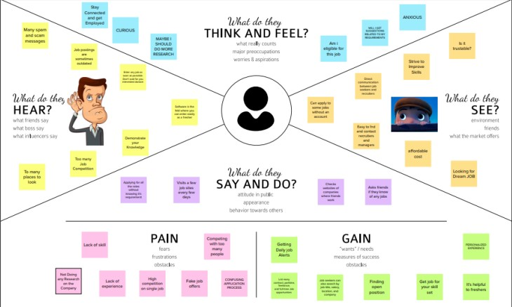

Ideation&Brainstroming Sorming:

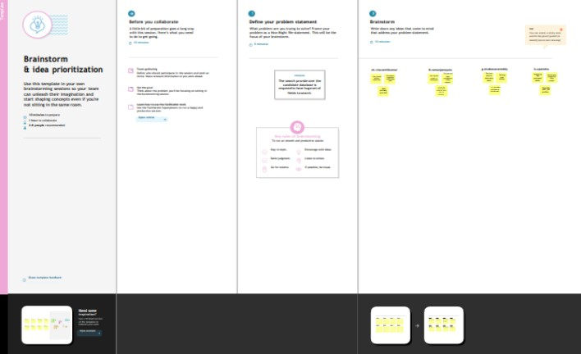

**PROBLEM SOLUTION FIT:**

The Problem-Solution Fit simply means that you have found a problem with your customer and that the solution you have realized for it actually solves the customer’s problem. It helps entrepreneurs, marketers and corporate innovators identify behavioral patterns and recognize what would work and why Purpose: ❑ Solve complex problems in a way that fits the state of your customers. ❑ Succeed faster and increase your solution adoption by tapping into existing mediums and channels of behavior. ❑ Sharpen your communication and marketing strategy with the right triggers and messaging. ❑ Increase touch-points with your company by finding the right problem-behavior fit and building trust by solving frequent annoyances, or urgent or costly problems. ❑ Understand the existing situation in order to improve it for your target group.

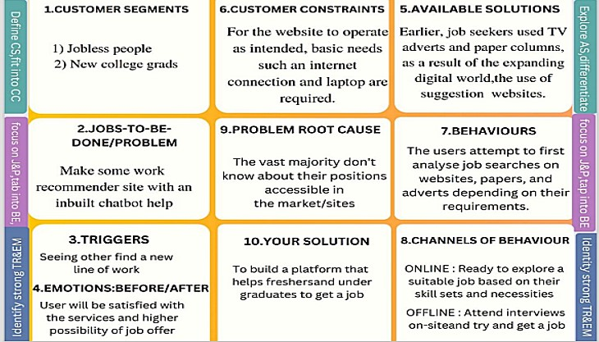

**DATA FLOW DIAGRAMS:**

Data Flow Diagrams: A Data Flow Diagram (DFD) is a traditional visual representation of the information flows within a system. A neat and clear DFD can depict the right amount of the system requirement graphically. It shows how data enters and leaves the system, what changes the information, and where data is stored. It shows how data enters and leaves the system, what changes the information, and where data is stored. The objective of a DFD is to show the scope and boundaries of a system as a whole. It may be used as a communication tool between a system analyst and any person who plays a part in the order that acts as a starting point for redesigning a system. The DFD is also called as a data flow graph or bubble chart.

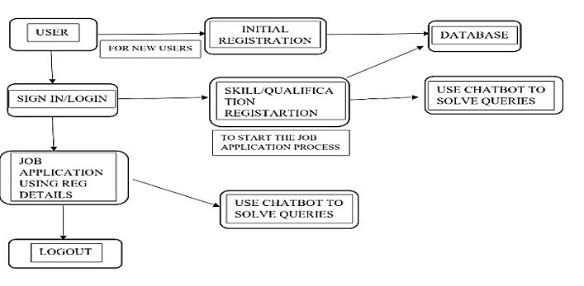

Condition”, IEEE Bombay Section Signature Conference (IBSSC)”, pp. 175- 179,

2020, doi:10.1109/ibssc51096.2020.9332162. [17] M. Alamelu, D.Sathish

Kumar, R. Sanjana, J.Subha Sree, A.Sangeerani Devi, D. Kavitha, “Resume

Validation and Filtration using Natural Language Processing”, 10th

International Conference on Internet of Everything, Microwave Engineering, Communication and Networks (IEMECON), pp. 412-430, 2021, doi:10.1109/IEMECON53809.2021.9689075. [18] Swaranjali Jugran, Ashish Kumar, Bhupendra Singh Tyagi, Mr. Vivek Anand,”Extractive Automatic Text

Summarization using SpaCy in Python & NLP”, International Conference on Advance Computing and Innovative Technologies in Engineering (ICACITE), pp. 582-585, 2021, doi:10.1109/icacite51222.2021.9404712. [19] S. Prathyusha, S. Jadhav, K. Kommu, M.S. Velpuru, “Text summarization using

NLTK with GUI interface”, 4th Smart Cities Symposium (SCS 2021), pp. 435-

442, 2021, doi: 10.1049/icp.2022.0369. [20] Meenakshi A. Thalor, “A

Descriptive Answer Evaluation System Using Cosine Similarity Technique”, International Conference.

## THANK YOU